Asian Art Museum

1-3rd floor perm. Collection area

2- Divine Buddhas show

- Compassion
-from two shows, pick an image which you feel expression the emotional aspect of compassion, what? how? why?
-can you point to an equivalent in western art or contemporary society?

- Power
-from the two shows, choose an image which you feel expresses an aspect of power what? How? Why?
-can you point to an equivalent in western art or contemporary society?

- The human Body
-Can you identify any fundamental difference and similarities between the eastern and western approaches to the human figure in art both historically and in the contemporary world? What? Why? Where?

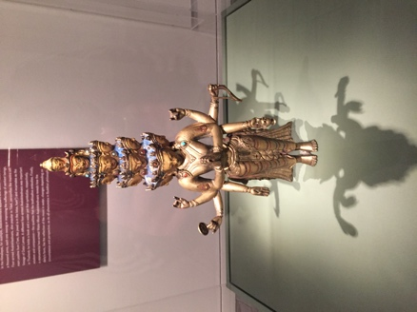
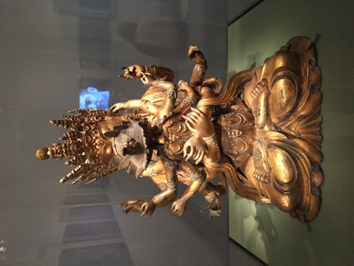
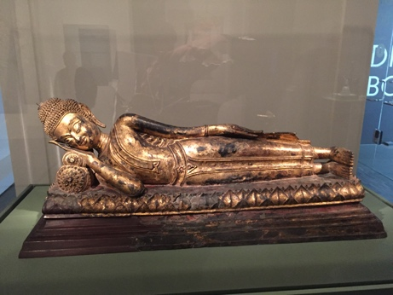
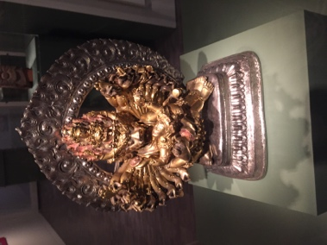
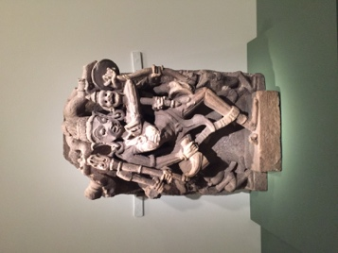
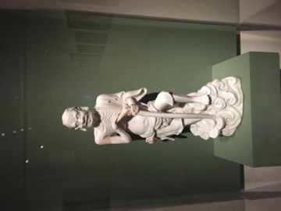
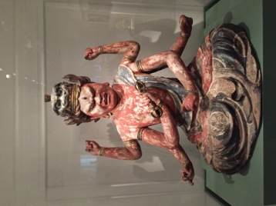
Divine Buddhas images show:

Death of Buddha

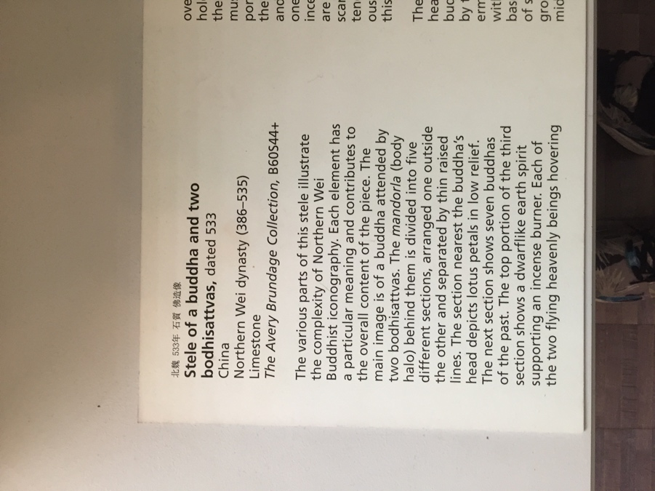
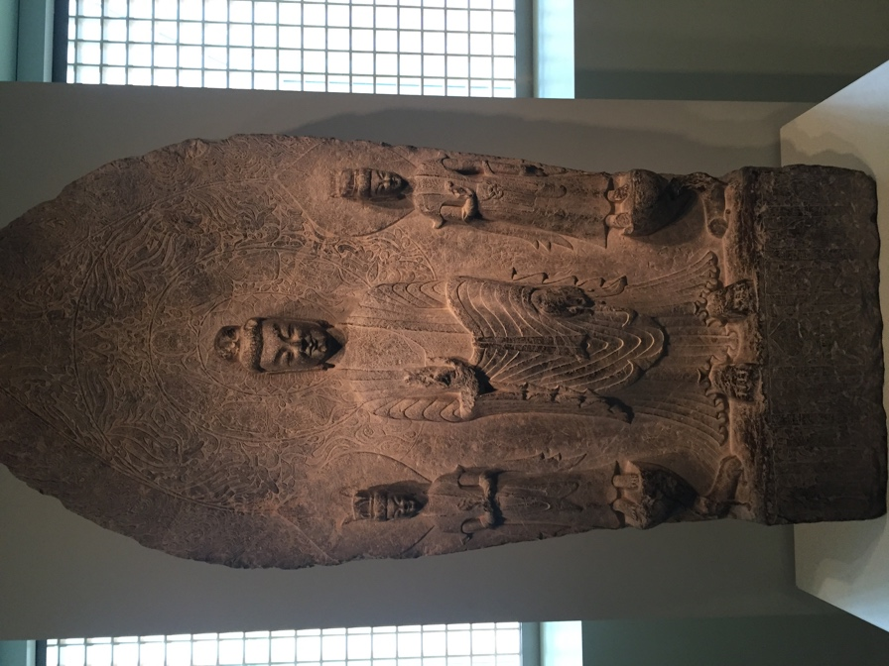
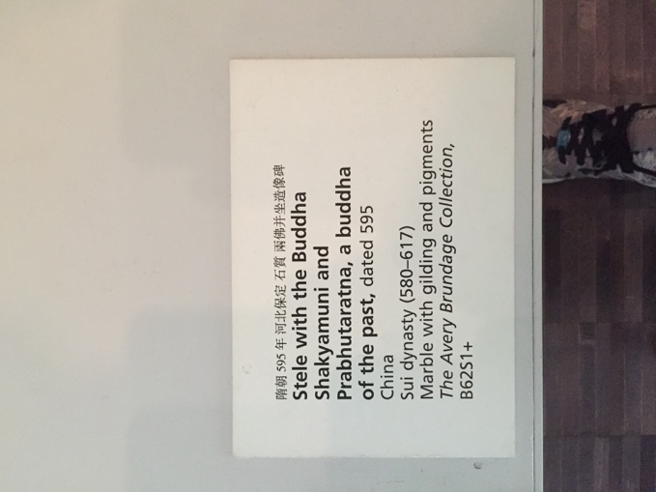
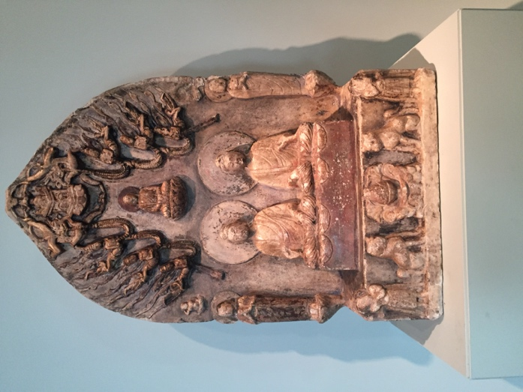
3rd floor

